CH3 Write up

Introduction

Within a community, interactions between plants for pollination form a continuum from competitive to facilitative. As fitness is the outcome of these associations, understanding them better has been of interest to ecologists for many years. The complexity of their study is compounded when moving beyond pairwise associations. All interactions are embedded in complex networks. Over the last few decades, network analysis has been use to explore these interactions at a community level. Most of these studies plant-pollinator visitation networks are generally summarized by species which gives an overview but less information about the interactions between individuals. Individual level forces drive dynamics at the species i.e. population and community level. By downscaling these species-level interaction networks, we can analyze the influence of traits that are known to influence pollination success, such as height, neighbourhood, flower number and neighbours on the network topology of the whole community of individual plants. Attributes are intrinsic characteristics of the nodes (size, floral number). Network topology are the patterns of relations.

There has been a recent interest in downscaling these networks which has aided an understanding of: trait-matching between plants and pollinators, spatial modules, conspecific density and specialization of pollinators. (Dupont 2011, Dupont 2014, Valverde 2015, Tur 2014, Rumeau 2018). [Gómez, Perfectti & Jordano, 2011](https://doi.org/10.1371%2Fjournal.pone.0016143); [Dupont, Trøjelsgaard & Olesen, 2011](https://doi.org/10.1111%2Fj.1600-0706.2010.18699.x); [Gómez & Perfectti, 2012](https://doi.org/10.1098%2Frspb.2011.2244); [Dáttilo et al., 2014](https://doi.org/10.1371%2Fjournal.pone.0099838); [Dupont et al., 2014](https://doi.org/10.1111%2Foik.01426); [Tur et al., 2014](https://doi.org/10.1111%2F1365-2656.12130); [Tur, Olesen & Traveset, 2015](https://doi.org/10.1111%2Foik.01668); [Kuppler et al., 2016](https://doi.org/10.1111%2Fnph.13858); [Valverde, Gómez & Perfectti, 2016](https://doi.org/10.1111%2Foik.02661)). These individual based networks can be analyzed as bipartite networks. Processes can be analyzed by projecting the bipartite plant-pollinator network into a unipartite plant-plant network, commonly done in social network analysis. This has been done for single species interaction networks to explore mating-probabilites (Gomez), assortive mixing (Valverde) and to explore how populations are structured by individuals sharing similar pollinator groups (Valverde). At the community level, these networks describe competition/facilitation probabilities, pollinator preferences as well as within population structure. Down-scaling to plant individuals can help resolve questions about intra vs interspecific pollinator sharing i.e. niche breadth. This approach can shed insight into the structure of interactions within a population (Valverde), but we see no reason it cannot shed light into the structure of interactions of a community. The number of potential interacting conspecifics is a greater mating pool.

Only two papers have looked at downscaling at the whole network level. Because it is very labour intensive to characterize very species rich ecosystems, we used a natural system, an arid shrubland where the shrubs and cactus were blooming, but too late in the year for annuals to grow. Thus, the majority of blooms available for foraging species came from a relatively small set of species

Pollinator responses to flowers are density-dependent. Flowering shrubs are an interesting system because they can represent multiple scales of floral density. Each plan forms a resource concentration, however the density of these concentrations vary through space. Finally, the relative density at a large scale can matter as well. Here, a network approach lets us better understand how the network rewires over the study seasons, and how intra and interspecific variation is visitation and sharing is influences by individual traits and neighbourhood composition. Density is known to mediate competition and facilitation between plants, and interaction are what build interactions networks. Therefore, this density-dependence should be visible in the network. We used functional groups, which are groups that use resources in similar ways.

Pollinator visitation networks are a quantitative method to visualize and analyze the many interactions within a community. Species that have a disproportionate effect on a community can be identified by looking at degrees of the many nodes (Dale and Fortin). In an individual network, then individuals can be identified. Those individual have traits etc etc.

Most network indices are sensitive to size (Dormann 2009, Tur), we used a null model approach. Tur said the differences in network structure may be due to differences in pollen use due to foraging patterns and behavioural differences, as well as conspecific variability. On the plant side, differences in network structure may arise from differences in individual traits and floral offerings, pollinator availability and behaviour. Plant pollinator use can be defined with linkage density i.e. abundance of visits and diversity of visits.

Seasonal decreases in floral density can lead to an increase in competition for floral resources between pollinators. Individual and classical species networks can be used together to explore shifts in community interactions. The role of certain structural characteristics of mutualistic network topology are hypothesized to promote species coexistence by reducing competition (Bastolla et al). For example, network specialization is expected to reduce inter-species competition and promote coexistence through resource partitioning (MacArthur 1955; Elton 1958; Levine & HilleRisLambers2009, Schoener 1974, Inouye 1978). When niche partitioning is occurring by flexible foragers in response to interspecific competition, network modularity is expected to increase (Spiesman and Gratton). In nested networks, both specialists and generalists tend to interact with generalists, specialist-specialist relationships are rarer. Modelling studies have shown nestedness reduces competition and promotes biodiversity (Bastolla et al). Differences in the structure between species and individual networks may be due to trait variability between individuals leading to differential responses in pollinators.

Differences in a scaled-down network from a species level network could be due to differences in attractiveness to pollinators.

Pollinator niche here is abundance of visits and diversity of pollinators.

Methods

Study site

The study area has an extent of x km2, and is located in the mouth of Sunset Cove on the property of the Sweeney Granite Mountains Desert Research Station within the Mojave National Preserve in California (34°46'26.5"N 115°39'31.3"W). The cove is created by tall rock formations on three sides, gently sloping and widening to the south. The diverse shrub and cactus community. Figure 1 lists the plant species.

Sampling design and experimental setup

The experiment was carried out between April 20th and May 14th, 2018 for a total of 19 sampling days. All observations were carried out between 9:00 AM and 5:30 PM in the absence of strong winds. This range of dates comprised the bloom periods of most shrubs at the site. Focal plants were chosen by walking in a line starting in a different quadrant of the study site each day to avoid confounding area by time of day. To avoid oversampling the most abundant species, up to six individuals of a single species was sampled per observer per day.

Flower-visitor observations were done by one or two observations in 10-minute observations. We recorded the number and identity of potential pollinators that made contact with reproductive parts of the flowers. This approach to creating a pollinator visitation network allows visitation rates to be standardized between individuals, compared with the frequently used method of transect walks. In our case, it is the number of foraging bouts and not floral visits per se. This is because insects were sampled mid foraging. However, anytime a visitor left and came back it was counted as a new visitor.

Melyrid beetles in the subfamily Dasytinae and pollen beetles Carpophilus sp. were excluded because while abundant, they were stationary deep within the flowers. It was not possible to extract them without disturbing the flowers and also not possible from large shrubs. Very small pollinators, such as the micro-beeflys (Mythicomyiidae) were excluded in analyses as it was not possible to consistently track their visits to, very large shrubs such as L. tridentata. Species known not to be pollinators ie nectar robbers, lady bugs were excluded. Visitors were identified on the wing. Insects were identified to species, genus, or family. Species were morphotyped within these categories. Morphotyping and RTU are still useful methods for characterizing and quantifying pollinator communities (Memmott & Godfray 1993; Oliver et al). The method, despite not being species level all the way through, still provides information about the linkages between different genera and functional groups. Also, because the pollinator diversity is really high at our study site, can’t do species ID on the wing. Wanted it to be a quantitative network. We collect x number of vouchers to verify the ids. Many species are undescribed at the site.

I counted the number of flowers and measured the height of each focal plant. I recorded the abundance and identity of blooming shrubs and cactus in a 3 m radius around the focal plant. 2018 was a drought year and annual bloom density was negligible. It was not feasible to count the blooms of all neighbouring shrubs, so the surrounding shrub density is a proxy for neighbourhood floral bloom density. I also measured the distance to and identity of the focal shrub’s nearest blooming neighbour, as well of the distance to the nearest blooming *L. tridentata*.

I recorded shrub phenology and estimated the site level blooming shrub density of each species using band transects on most study days.

I also used pan traps placed in open areas to track pollinator population changes throughout the study period. I quantified the number of ‘large bodied’ pollinators to reflect the sizes of those observed during the experiments (hereafter just ‘pollinators’).

Data analysis

Pollinator-mediated interactions, density-dependence

To explain floral visitation in response to individual floral traits, number, patch density and site-level density, generalized linear mixed models were fit with species included as a random effect. Compared the model’s using AIC and likelihood ratio tests. Compared to intercept only models. When AIC < 2 and no difference in likelihood ratio test, chose the simpler of the models.

I used imputeTS to fill in densities for the days they weren’t sampled using the linear interpolation because I expect to see a trend but no seasonality.

To test for spatial autocorrelation, to look for pollination hotspots that may arise from habitat preferences rather than floral preferences, we used Moran’s I and Geary’s C to test for autocorrelation of visitation rates.

*We also looked for clustering in linkage density, betweenness and Bluthgren’s D were used (n = 373). This was calculated using k = 4 nearest neighbours*

Individual plant traits

*To determine how individual plant traits influence network topology, the network trait was used as a response variable, and the individual traits and neighbourhood densities as predictor variables in GLMM with the shrub species as a random effect.*

These use centrality measures: betweenness

Betweenness centrality quantifies the number of times a node acts as a bridge along the shortest path between two other nodes

Assortativity coefficients

Using the one-mode graphs, we calculated assortativity coefficients for interactions for all individuals at the community level (interspecific) and within each species. We calculated assortativity for species, number of flowers, height, surrounding density, conspecific density and heterospecific density, surround shrub diversity. This was calculated using igraph, and the weighted one-mode networks, with each vertex labelled with trait. To test for significance, I created 1000 null models and projected them to one-mode. I applied the same vertice labels to the random network so that the values and abundances would be the same. Calculated assortativity for each null model and compared them to the observed values using Z-scores.

Functional group modularity

To test for how functional groups of pollinators structure the plant community. I used the individual based network with the Beckett (2016) algorithm. This is a recent algorithm for weighted networks. To test if the system is significantly modular, we compared our network to a null model.

We computed modularity for two networks: One is the individual-based, quantitative two-mode network. This explore how pollinator functional groups form modules….

To test for traits and neighbourhoods’ influence into the creation of modules, we fit GLMM with the module as a factor as a predictor, and the traits as response variables. We used the species as a random slope and intercept because the traits also vary as a response to species and we expect that the modules will be structured by species.

We projected the two-mode network into a one-mode, binary network. Each link between individuals is a shared pollinator functional group (or quantitative?). This tests for how functional groups structure the plant community into modules of interacting individuals.

Using the one-mode network, we calculated the number of interacting conspecifics and heterospecifics.

For this analysis, the one mode network is one link per pair of individuals, regardless how many visits they get, this is because we are looking at the size of the potential mating pool.

Individual Centrality Measures

Compute these from plant-plant onemode network.

Local centrality – degrees links per individual ie visitation for bipartitie but but in one-mode this is the size of the conspecific data pool and/or the number of potential interactors. Cd

Nodes with many links have on average shorter distances to the rest of the nodes

Global centrality - It calculates the shortest paths between all nodes, then assigns each node a score based on its sum of shortest paths and is useful for finding the individuals who are best placed to influence the entire network most quickly.

Betweenness centrality: Measures the number of times a node lies on the shortest path between other nodes. Important to the cohesiveness of a network.

Closeness centrality: This measure calculates the shortest paths between all nodes, then assigns each node a score based on its sum of shortest paths. For finding the individuals who are best placed to influence the entire network most quickly. Cc

Eigancentrality: y calculating the extended connections of a node, EigenCentrality can identify nodes with influence over the whole network, not just those directly connected to it. It measures the relative importance of a species “hen measures the relative importance of species by assigning them a score on the basis that an interaction with more influential species contribute more to a species’ score than the same interaction with a low-scoring species (Allesina & Pascual 2009). (1) (PDF) Analyzing ecological networks of species interactions. Available fromhttps://www.researchgate.net/publication/314278873_Analyzing_ecological_networks_of_species_interactions [accessed Mar 12 2019].

Low Cd, high Cc, species plays a key role interacting with other important species

Node centrality not explored prior to 2009

**We can investigate the topological importantance of plant individuals in relation to their floral density and neighbours.

Gonzalez et al 2009 used importance ie centrality measures of decomposed networks to compare importance to generalization.

“topological importance’ Jordan 2003. T1 – influence on pollinators. T2 – influence on other plants through shared pollinators

Path

Path mean connectivity. Path captures the indirect interactions in a network, andindividual nodes benefit (or suffer) from indirect relationshipsbecause friends might provide access to favors from their friendsand information might spread through the links of a network.Path is closely related to small-world phenomenon.Path is related to many centrality measures

Ways to integrate cluster analysis

Then, we ran a hierarchical clusteranalysis based on among‐plant dissimilarity (Bray‐Curtis) in terms of the pollinator species using the average agglomerative method(Everitt & Hothorn, 2011; Goslee & Urban, 2007). Cluster uncer ‐tainty was assessed with bootstrap resampling methods (1,000 replicates) implemented in the pvclust package of R 3.3.3. (Suzuki& Shimodaira, 2006). While the cluster analysis allowed us to iden ‐tify similarity between plant species in terms of pollinator identityand frequen

., 2017). Müller’s index was calculated with the PAC function implemented in the bipartite packaged for R

Affiliate networks

Temporal Networks

### Creating temporal networks

There are two principal types of temporal networks, time‐ordered and time‐aggregated networks (Blonder *et al*. [2012](https://besjournals.onlinelibrary.wiley.com/doi/full/10.1111/1365-2656.12418#jane12418-bib-0017)). In a time‐ordered network, each edge is encoded with start and end times, capturing the complete set of information about when edges (i.e. interactions/associations in social analysis) occurred and their duration, and so what edges co‐occurred. Such time‐ordered data can be used to map the topological flow of information or pathogens through networks when the ordering of interactions or associations are considered to be important (Blonder & Dornhaus [2011](https://besjournals.onlinelibrary.wiley.com/doi/full/10.1111/1365-2656.12418#jane12418-bib-0016)). Blonder *et al*. ([2012](https://besjournals.onlinelibrary.wiley.com/doi/full/10.1111/1365-2656.12418#jane12418-bib-0017)) provide a useful *R* package *time ordered* to perform some analyses on these types of networks.

Time‐aggregated networks, in contrast, maintain the same form as regular aggregated networks (an adjacency matrix). Here, a new network is calculated for each time slice, such as for every sampling event, week, month, season or year. Creating these networks is relatively simple as they only require the input data to be subset for each period.

Finally, a useful measure of temporal stability is the lagged association rate (Whitehead [1995](https://besjournals.onlinelibrary.wiley.com/doi/full/10.1111/1365-2656.12418#jane12418-bib-0138)). This measure calculates the probability that a given dyad is re‐observed after a given time period. This can be estimated at the network level, for different classes of individuals, or at the dyadic level. The lagged association rate is useful for describing and modelling the temporal scales over which social behaviour processes operate, or for comparing how these differ between different classes of individuals

Which indices are robust to network size?

H2 – index of specialization

Bluthgen’s d – also specialization

Results

Over a period of 19 days I observed 395 individuals, comprising seven species of shrub and three species of cactus for a total of 66 hours of observation. 394 observation periods, a total of 635 potentially pollination visits were recorded. Nectar robbing and visits by non-pollinating insects excluded. 430 visits were to shrubs and 205 were to cactus. The pollinators make up 10 functional groups spanning 62 RTU of visitors. All visitors, with the exception of Costa’s hummingbird Calpte costa were insects. See Appendix for full list of visitors and the functional group they were assigned to.

Shrub phenology:

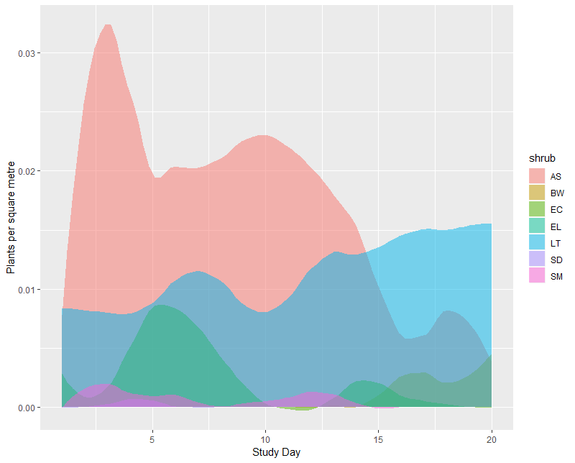

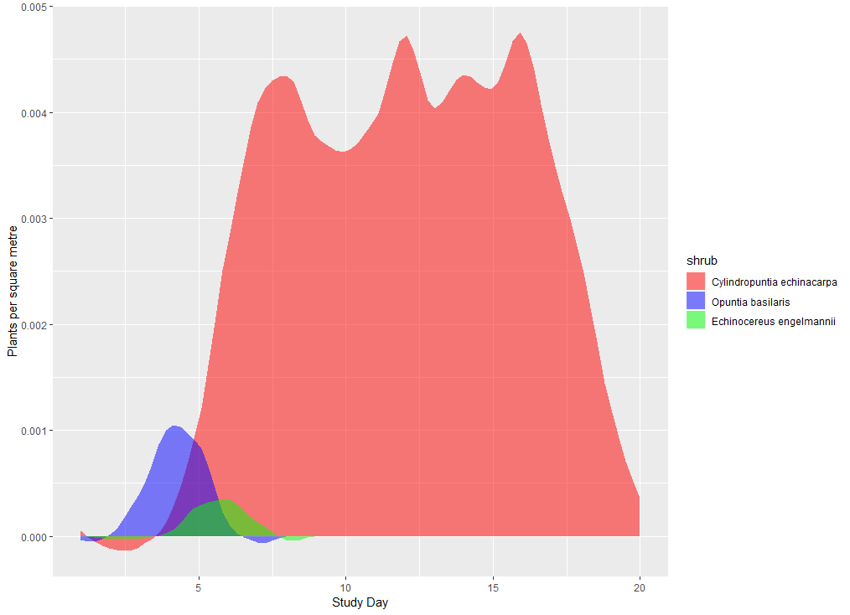

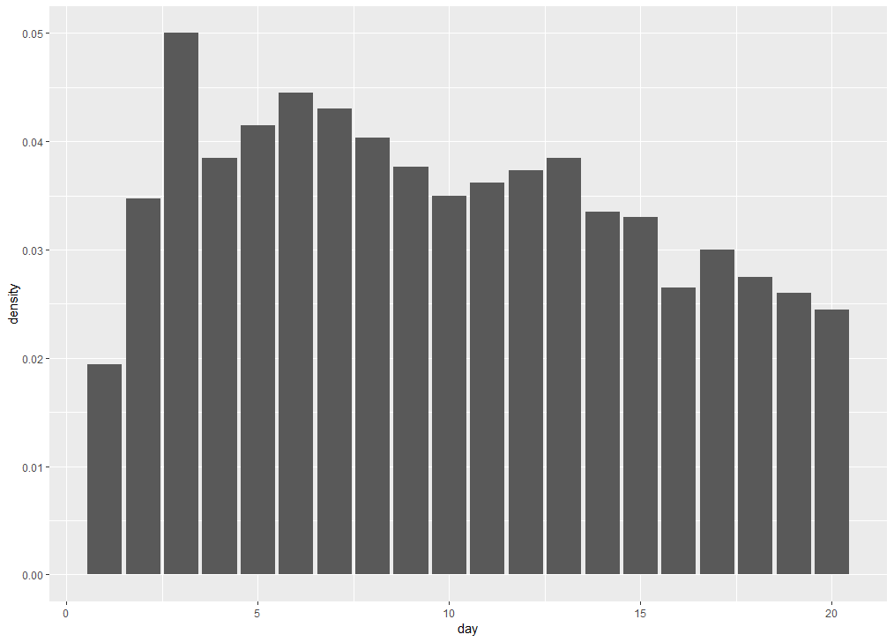

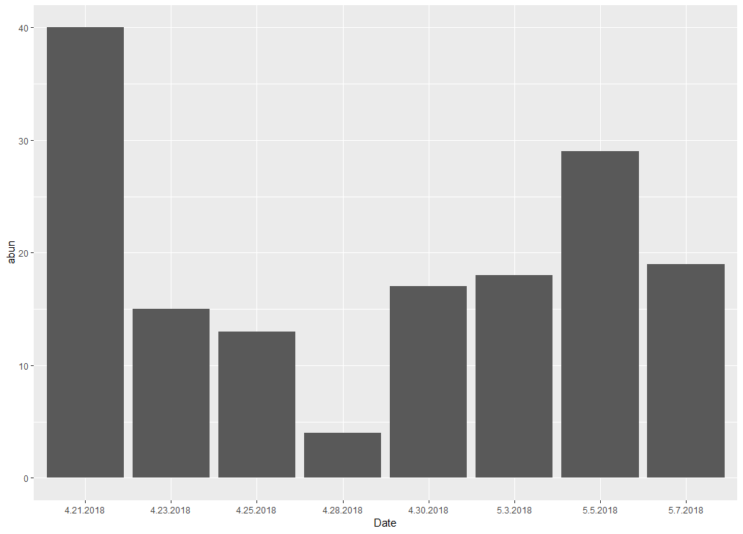

Visitation rates

Visitation rates increased with shrub density (Table 3). There was significant interaction between site level density and individual floral number. Plants with more flowers did much better than plants with less flowers at high site level densities, but it doesn’t matter as much as at lower site level densities. There was no influence of shrub species richness on visitation.

* This is evidence for facilitation/mutualisms between co-blooming shrubs.
* This is also consistent however with an increase in competition/a saturation effect. This is scale dependency: individual attractiveness is dependent on site level density. As the site density intensifies, so does selection between individuals based on the number of flowers they have.

Spatial autocorrelation

There was no spatial autocorrelation detected for visitation (Moran’s: -0.055108, p = 0.953, Geary: 1.0442, p = 0.8145).

* This suggests the absence of hotspots of pollinator activity, both globally through the site and more locally.

Functional group modularity

We found that q = 0.59, p <0.0001 somewhat modular. Significant when compared to random networks. No difference in flower number, height, visitation rates or shrub density between modules.

Associatitivity of the networks

Based on 17 functional groups

|  |  |
| --- | --- |
| **assort.sp** | 0.1810363690 |
| **assort.fl** | 0.1007167403 |
| **assort.h** | 0.2328732123 |
| **assort.density** | 0.0186633679 |
| **assort.con.density** | 0.1086431747 |
| **assort.het.density** | 0.0007042354 |
| **assort.s** | -0.0025106048 |
| Unweighted: |
| **assort.sp** | 0.142863907 |
| **assort.fl** | 0.079231390 |
| **assort.h** | 0.201107553 |
| **assort.density** | 0.028110262 |
| **assort.con.density** | 0.101288452 |
| **assort.het.density** | 0.004864477 |
| **assort.s** | 0.004716074 |

Species network vs individual network characteristics

Build 1000 null networks of i-sp networks. Calculate parameters. Does the observed network fall into the 95% confidence interval for the null network derived parameter?

Alternatively, compare each observed parameter to null using z-score to describe the effect size of that parameter, and then compare the difference between each to each other.

|  |  |  |  |  |  |  |
| --- | --- | --- | --- | --- | --- | --- |
|  | network.sp | network.shrub | network.cactus | network.indiv | network.indiv.shr | network.ind.cac |
| connectance | 0.195081967 | 0.245614035 | 0.538462 | 0.027464 | 0.030702 | 0.115926 |
| web asymmetry | -0.718309859 | -0.78125 | -0.625 | -0.58219 | -0.47465 | -0.69048 |
| links per species | 1.676056338 | 1.53125 | 1.3125 | 1.325342 | 1.290323 | 1.27381 |
| number of compartments | 2 | 2 | 1 | 7 | 7 | 2 |
| compartment diversity | 1.136915286 | 1.149193967 | NA | 1.298515 | 1.395488 | 1.16658 |
| cluster coefficient | 0.163934426 | 0.245614035 | 0.615385 | 0.012987 | 0.0125 | 0.028169 |
| nestedness | 21.38699296 | 31.08283247 | 13.1607 | 2.057853 | 3.0394 | 9.364582 |
| NODF | 32.13507152 | 33.93652137 | 65.12346 | 7.451157 | 7.632228 | 33.86411 |
| weighted nestedness | 0.392810818 | 0.287985288 | 0.681249 | 0.508026 | 0.425396 | 0.657818 |
| weighted NODF | 16.21011012 | 17.39278494 | 54.78395 | 2.285332 | 2.699228 | 9.034105 |
| interaction strength asymmetry | -0.227115633 | -0.27784834 | -0.35307 | -0.24618 | -0.17908 | -0.38224 |
| specialisation asymmetry | 0.214064984 | 0.331941389 | 0.250936 | 0.30968 | 0.253064 | 0.521379 |
| linkage density | 4.771531516 | 5.569392943 | 2.706056 | 10.82269 | 8.409756 | 13.90551 |
| weighted connectance | 0.067204669 | 0.087021765 | 0.169129 | 0.037064 | 0.038755 | 0.165542 |
| Fisher alpha | 43.22443798 | 39.64312224 | 5.861291 | 420.51 | 348.1018 | 90.3156 |
| Shannon diversity | 3.744086569 | 3.679034078 | 1.93221 | 5.739732 | 5.443934 | 4.411858 |
| interaction evenness | 0.583785847 | 0.614302518 | 0.527413 | 0.600812 | 0.597039 | 0.646177 |
| Alatalo interaction evenness | 0.438401524 | 0.451771594 | 0.472234 | 0.761504 | 0.785708 | 0.741201 |
| H2 | 0.615059075 | 0.592791421 | 0.208879 | 0.558604 | 0.488607 | 0.580302 |
| number.of.species.HL | 10 | 7 | 3 | 61 | 57 | 13 |
| number.of.species.LL | 61 | 57 | 13 | 231 | 160 | 71 |
| mean.number.of.shared.partners.HL | 2.311111111 | 2.761904762 | 3.333333 | 0.121858 | 0.110902 | 0.589744 |
| mean.number.of.shared.partners.LL | 0.554644809 | 0.583333333 | 1.076923 | 0.135554 | 0.144733 | 0.592757 |
| cluster.coefficient.HL | 0.27574545 | 0.352345981 | 0.767355 | 0.103876 | 0.109026 | 0.466987 |
| cluster.coefficient.LL | 0.348818898 | 0.379069767 | 0.923577 | 0.035317 | 0.04133 | 0.133208 |
| weighted.cluster.coefficient.HL | 0.267429594 | 0.225598924 | 0.074121 | 0.019346 | 0.028616 | 0.013561 |
| weighted.cluster.coefficient.LL | 0.866860742 | 0.920958787 | 0.661725 | 0.263532 | 0.233048 | 0.363956 |
| niche.overlap.HL | 0.111547857 | 0.114485722 | 0.651097 | 0.014071 | 0.016032 | 0.030068 |
| niche.overlap.LL | 0.222369044 | 0.263190085 | 0.661038 | 0.081781 | 0.08129 | 0.389658 |
| togetherness.HL | 0.083563302 | 0.083362728 | 0.212121 | 0.002968 | 0.003681 | 0.012688 |
| togetherness.LL | 0.13873224 | 0.196115288 | 0.397436 | 0.023894 | 0.025439 | 0.175509 |
| C.score.HL | 0.65153896 | 0.69366492 | 0.333333 | 0.958969 | 0.956359 | 0.809869 |
| C.score.LL | 0.590561627 | 0.548254316 | 0.181818 | 0.886015 | 0.883063 | 0.480494 |
| V.ratio.HL | 8.492468134 | 8.720338983 | 5.727273 | 13.75077 | 9.619862 | 23.69128 |
| V.ratio.LL | 1.132289628 | 0.715388858 | 1.095238 | 0.521392 | 0.56418 | 0.589789 |
| discrepancy.HL | 58 | 45 | 2 | 311 | 214 | 43 |
| discrepancy.LL | 54 | 44 | 2 | 327 | 234 | 49 |
| extinction.slope.HL | 1.623927791 | 1.555743051 | 1.566032 | 1.484163 | 1.539852 | 1.347619 |
| extinction.slope.LL | 7.572849686 | 9.346037603 | 7.720112 | 2.510613 | 2.43762 | 2.681406 |
| robustness.HL | 0.619139081 | 0.606721878 | 0.606346 | 0.595968 | 0.604494 | 0.572004 |
| robustness.LL | 0.855574176 | 0.869400332 | 0.862039 | 0.708413 | 0.702787 | 0.72304 |
| functional.complementarity.HL | 434.7017473 | 273.0027564 | 202.5422 | 239.1016 | 191.7319 | 79.31409 |
| functional.complementarity.LL | 495.216097 | 298.2138008 | 236.3746 | 303.0285 | 231.1036 | 83.24064 |
| partner.diversity.HL | 1.85015243 | 2.138600972 | 1.245114 | 2.67535 | 2.337515 | 3.042767 |
| partner.diversity.LL | 0.679704907 | 0.572614895 | 0.563119 | 0.558927 | 0.638634 | 0.391737 |
| generality.HL | 7.404265463 | 9.223208359 | 3.588922 | 19.69136 | 14.70441 | 26.19489 |
| vulnerability.LL | 2.138797569 | 1.915577527 | 1.82319 | 1.954014 | 2.115098 | 1.616131 |

Influence of density and individual traits on network topology

Additive model:

Fixed effects:

Estimate Std. Error z value Pr(>|z|)

(Intercept) 0.38125 0.41853 0.911 0.3623

shrub.density 0.08558 0.04204 2.036 0.0418 *

N.flowers.scaled 0.40650 0.09743 4.172 3.01e-05 ***

site.density -4.53886 10.25546 -0.443 0.6581

Site density was not measured each day. There is a significant interaction, however the positive effect of individual flower number was unchanged – it just became more positive. Therefore, we feel comfortable still including it in models.

**Summary results:**

Table 3: Results of GLMM of density-dependence. P-values from type 3 wald’s chisq test

|  |  |  |  |
| --- | --- | --- | --- |
| Variable | Coeff | Chisq | p |
|  |  |  |  |
| Shrub.density | 0.08464 | 5.1999 | 0.022589 |
| N.flowers.scaled | -0.44179 | 1.7254 | 0.189004 |
| Im.density | -3.46973 | 0.1342 | 0.714073 |
| Nflowers:im.density | 24.61896 | 6.6971 | 0.009657 |

Appendix

Imputation: Missing values (4) of site level density for imputed using the package imputeTS (cite) to be able to use the most response data in the analysis. All species were imputed individually because different plants have different flowering strategies. We used time series because the number of flowers opened each days has temporal dependencies. “his process is a commonly used statistical method for substituting missing values in a time series with values following the same temporal or spatial pattern created by existing data (Schneider, 2001; Moritz, 2015)

“

Closeness centrality: This measure calculates the shortest paths between all nodes, then assigns each node a score based on its sum of shortest paths. For finding the individuals who are best placed to influence the entire network most quickly.

Network level influence of plant traits

Using the one-mode graphs, we calculated assortativity coefficients for interactions for all individuals at the community level (interspecific) and within each species. We calculated assortativity for species, number of flowers, height, surrounding density, conspecific density and heterospecific density, surround shrub diversity. This was calculated using igraph, and the weighted one-mode networks, with each vertex labelled with trait. To test for significance, I created 1000 null models and projected them to one-mode. I applied the same vertice labels to the random network so that the values and abundances would be the same. Calculated assortativity for each null model and compared them to the observed values using Z-scores.

Table 1: Imputation of site density measurements.

|  |  |  |  |  |  |
| --- | --- | --- | --- | --- | --- |
| Parameter | Mean | | Standard deviation | | % DAta |
|  | Before | After | Before | After | Before |
| LT | 0.011858974 |  | 0.00312757 |  | 76.5% |
| SD | 7.69E-05 |  | 0.00027735 |  | 76.5% |
| SM | 0.000521368 |  | 0.000874754 |  | 76.5% |
| SC | 0.002653846 |  | 0.002230327 |  | 76.5% |
| AS | 0.015478632 |  | 0.009804953 |  | 76.5% |
| EL | 0 |  | 0 |  | 76.5% |
| EC | 0.002405983 |  | 0.003057944 |  | 76.5% |
| PP | 0.000115385 |  | 0.000416025 |  | 76.5% |
| HH | 3.85E-05 |  | 0.000138675 |  | 76.5% |
| BW | 0.001 |  | 0.001607275 |  | 76.5% |

Table 2: List of shrub species, number of observation periods and blooming period

|  |  |  |  |  |
| --- | --- | --- | --- | --- |
| Foundation plant species | Observation periods and length | Mean height +/- SD | Mean floral number | Blooming period |
| Acamptappapus | 96 |  |  |  |
| Buckwheat | 31 |  |  |  |
| Ericameria cooperi | 55 |  |  |  |
| Ericameria lineafolia | 4 |  |  |  |
| Larrea tridentata | 80 |  |  |  |
| S Mexicana | 12 |  |  |  |
| Salvia dorri | 13 |  |  |  |
| Hedgehog | 5 |  |  |  |
| Prickly pear | 29 |  |  |  |
| Silver cholla | 69 |  |  |  |

Appendix A

|  |  |
| --- | --- |
| Candidate Model | AIC |
| density * N.flowers.scaled + im.site | 1337.569 |
| density + N.flowers.scaled * im.site | 1333.017 |
| con.density + N.flowers.scaled + im.site | 1339.356 |
| con.density + N.flowers.scaled * im.site | 1334.943 |
| con.density + het.density + N.flower | 1334.161 |
| shrub.density + N.flowers.scaled * im.sit | 1332.177 |
| shrub.density * N.flowers.scaled * im.sit | 1332.609 |
| density * N.flowers.scaled * im.site | 1333.037 |
| shrub.density + N.flowers.scaled * im.site + S | 1334.177 |
| S + N.flowers.scaled * im.site | 1335.671 |

Anova on two similar models. Adding interaction term does not improve model.

Df AIC BIC logLik deviance Chisq Chi Df Pr(>Chisq)

m6 7 1332.2 1360.0 -659.09 1318.2

m7 10 1332.6 1372.3 -656.30 1312.6 5.5682 3 0.1346

|  |  |  |  |  |  |
| --- | --- | --- | --- | --- | --- |
|  | Observed value (weighted) | Mean Null value (Patefield) | SD | Z-score | p |
| Species | 0.1810363690 | -0.006076719 | 0.001991565 | 93.9528 | *** |
| Number of flowers | 0.1007167403 | -0.006747148 | 0.004410240 | 24.3669 | *** |
| Height | 0.2328732123 | -0.006566730 | 0.004487989 | 53.35128 | *** |
| Density | 0.0186633679 | -0.006360445 | 0.004448037 | 5.625811 | ** |
| Conspecific density | 0.1086431747 | -0.005619527 | 0.004467686 | 25.57537 | *** |
| Heterospecific density | 0.0007042354 | -0.006319569 | 0.004539893 | 1.54713 |  |
| Diversity | -0.0025106048 | -0.006647620 | 0.004562993 | 0.9066451 |  |
| Cluster | 0.0016619081 | -0.006264240 | 0.002303663 | 3.440672 | ** |

|  |  |  |  |  |  |  |  |  |  |
| --- | --- | --- | --- | --- | --- | --- | --- | --- | --- |
|  |  | early |  |  | mid |  |  | later |  |
|  | species | indiv | Floral cluster | Species | indiv | Floral cluster | Species | indiv | Floral cluster |
| H2 | 0.441 | 0.490 | 0.252 | 0.483 | 0.622 | 0.216 | 0.587 | 0.555 | 0.362 |
| Null | 0.12  ± 0.018 | 0.21  ± 0.027 | 0.090  ± 0.018 | 0.085  ± 0.013 | 0.209 ± 0.028 | 0.062  ± 0.014 | 0.073  ± 0.017 | 0.218  ± 0.022 | 0.076  ± 0.017 |
| Delta H | **0.321** | **0.28** | **0.162** | **0.398** | **0.413** | **0.154** | **0.514** | **0.337** | **0.286** |
| Z-score | **18.15** | **10.52** | **8.94** | **29.77** | **14.5** | **11.39** | **30.81** | **15.70** | **16.46** |
| WNODF | 19.999 | 5.86 | 37.72 | 22.23 | 3.97 | 50.17 | 24.21 | 4.68 | 30.93 |
| Null | 44.61  ± 4.12 | 7.79 ± 1.08 | 47.3  ± 4.43 | 54.71  ± 4.96 | 7.54  ± 0.75 | 50.47  ± 4.26 | 55.8  ± 5.51 | 11.43  ± 1.31 | 57.49  ± 6.00 |
| Z-score | **-5.976** | **-1.8** | **-2.17** | **-6.56** | **-4.75** | **-0.07** | **-5.74** | **-5.17** | **-4.43** |
| Modularity | 0.42 | 0.58 | 0.32 | 0.47 | 0.63 | 0.28 | 0.49 | 0.58 | 0.33 |
| Null (mean, sd) | 0.17  ± 0.02 | 0.42  ± 0.02 | 0.15  ± 0.02 | 0.14  ± 0.02 | 0.42  ± 0.01 | 0.12  ± 0.02 | 0.12  ± 0.02 | 0.36  ± 0.015 | 0.11  ± 0.02 |
| Z-score | **13.83** | **9.47** | **8.902** | **19.75** | **15.76** | **9.931** | **21.35** | **14.61** | **12.78** |
| Connectance | 0.294 | 0.099 | 0.5411 | 0.32 | 0.093 | 0.575 | 0.33 | 0.11 | 0.5 |
| Null | 0.3935 ±  0.017 | 0.12  ± 0.003 | 0.573  ± 0.024 | 0.455  ± 0.018 | 0.13  ± 0.003 | 0.67  ± 0.02 | 0.52  ± 0.017 | 0.153  ± 0.003 | 0.595  ± 0.030 |
| Z-score | **-5.840** | **-8.287** | **-8.29** | **-7.654** | **-11.99** | **-11.99** | **-10.79** | **-12.39** | **-12.39** |
| Evenness | 0.636 | 0.648 | 0.726 | 0.62 | 0.646 | 0.765 | 0.598 | 0.649 | 0.673 |
| Null (mean, sd) | 0.736  ± 0.006 | 0.69  ± 0.004 | 0.776  ± 0.006 | 0.75  ± 0.004 | 0.71  ± 0.004 | 0.818  ± 0.005 | 0.746  ± 0.005 | 0.715  ± 0.004 | 0.749  ± 0.005 |
| Z-score | **-18.15** | **-10.52** | **-8.94** | **-29.768** | **-14.50** | **-11.41** | **-30.81** | **-15.701** | **-16.460** |

and a trait-based network. The trait-based network was built by clustering floral display sizes using vegdist and hclust in vegan (vignette). The tree was cut at five clusters to maximize the differences between the clusters while maintaining ease of interpretation (see Appendix for dendrogram). Only plants that were part of the network were clustered (i.e. plants with no recorded visits were excluded) – any chance they were visited by the exclusions tho? Does not matter?.

Individual vs species interaction networks

For each networks, several frequently used network descriptors were calculated using bipartite (vignette). H2` is the degree of complementary specialization of the whole network of interacting species. It measures the deviation of observed interactions from those expected given the marginal totals of the species. This quantitative measure ranges from 0 and 1; the higher the selectivity of the species, the higher H2 is for the network. H2 does not vary significantly with network size (Bluthgen and Menzel, 2006). Weighted nestedness (WNODF) is a quantitative measure describing the hierarchy of the interactions of the network. In nested networks, specialized nodes i.e. those with fewer interactions are linked with generalized nodes i.e. well connected nodes (Almeida-Neto & Ulrich, 2011). This measure ranges from 0 to 100. Weighted connectance is the linkage density divided by the total number of interactors (species or individuals) (Tylianakis et al. 2007). It is a central network property that drives other network properties such as nestedness (Poisot 2014). It measures of the complexity of the network .

The modularity of each network was assessed using DirtLPA algorithm implemented in bipartite (Beckett 2016). Modularity is a measure of the extent to which a network is subdivided into modules. Modular networks are those whose modules are comprised of members than interact strongly within the module and weakly between modules. Modularity describe how the network is split into cluster or modules of species or individuals that are more likely to interact with each other than outside the module. In a bipartite network, modules are a blend of interacting plants and pollinators.

For each of the observed networks, 1000 random networks were generated holding the totals of rows and columns fixed based on Patefields’ (1981) algorithm (permatfull, vegan). Each of the three indices and modularity were calculated for each random network. Z-scores were calculated to assess significance of results and facilitate comparison between the different networks. Z-scores were calculated using: Z:Score = (Observed value - mean (null)/sd*null). Positive value denote the observed value is higher than the mean of the null distribution.